Sisterhood - Wednesday 26th July, 2023 - HeartSpeak
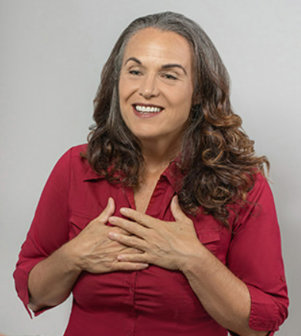
With Dr Anne Jensen
Dr. Jensen is forward-thinking healer who has earned her DPhil (PhD) in Evidence-based Health Care from Oxford University. She is a clinical researcher and published author on emotional healing and stress reduction, and her clinical and research interests lie in the relationship between stress and emotions and health and behaviour.

At Oxford, the focus of her research was on the accuracy and precision of muscle response testing (MRT), and her results represent a rigorous proof of concept, confirming the validity of MRT.
Dr Jensen’s diverse background in physical health, kinesiology, psychology, yoga and sports performance has given her a profound appreciation of the importance the relationship between mind and body.

Through her broad background, her empathic ability, her sense of curiosity and common sense, she developed HeartSpeak, a unique and empowering stress-reduction tool. Dr Jensen has taught HeartSpeak in more than 12 countries and in 5 languages, and its reach is growing yearly.

In addition to offering HeartSpeak seminars, events and courses, speaking at conferences and continuing her clinical research, Dr Jensen maintains a private practice consulting with people from around the world on mind body wellness.

What is HeartSpeak?

HeartSpeak is an exciting new emotional healing and stress reduction tool developed by Dr. Anne Jensen. HeartSpeak uses the premise that there are two parts to the mind: The Logical Mind and the Emotional Mind. Our Emotional Mind is often the seeker of ‘truth’ that is so often drowned by our Logical Mind. Yet being separated from your truth is one of the classic triggers of anxiety, depression and self-loathing.

HeartSpeak is: Fast – it typically takes only one or two sessions for clients or practitioners to experience results. Friendly – HeartSpeak gently listens to and works with the heart and emotions, rather than against them, delivering answers about repeated patterns. Fear-busting – HeartSpeak helps break old, fearful, futile patterns so healthier, more expansive ones can quickly emerge.

Held at the Women’s Centre 418 Shakespeare Street, West Mackay
5.30pm to 7pm Wednesday 26th July, 2023. Please ring 13000 22682 to let us know you are coming – so we know how many chairs to put out. To join us on Zoom email Melissa Giraldo melissa@bantacsfinancialsolutions.com.au

